Sponsorship Selection Form
To become a sponsor, please return this form at your earliest convenience. Thank you so much! You can send the check later, by March 15, 2025, as detailed below.
1. Sponsorship Options (Please mark the one you choose)
______ Diamond Partner - $10,000
For questions, please contact
Grace Yan
Email: yang@mst.edu
Phone: 915-841-8074
______ Platinum Partner - $5,000
______ Gold Partner - $2,500

2. Organization of Sponsor/Exhibitor
Please provide the following information of your organization in order for us to include your organization on the conference website and in the conference program.
Organization Name: _____________________________________
Organization Website: __________________________________

3. Sponsor/Exhibitor Contact Person’s Information
Name: ___________________________________________________
Title: ____________________________________________________
Address: ________________________________________________
Email: ___________________________________________________
Phone: __________________________________________________
Date Form Completed: ________________________________
4. Conference Attendees from Your Organization
Please provide the following information of the conference attendees from your organization, which will be printed on their name badges.
 | Name | Title | Affiliation
1
2
3
4

5. Payment Options
If you want to pay it using a check, please make check payable to:

Missouri University of Science and Technology

With the note of “15 ACWE Sponsorship”.

Please mail the check to the following address by March 15, 2025.
Guirong Yan, 13301 Jenna Ln, Rolla, MO 65409

If you want to pay it using a different way or need to pay it later than March 15, 2025, please reach out to Grace Yan at yang@mst.edu.

Appendix

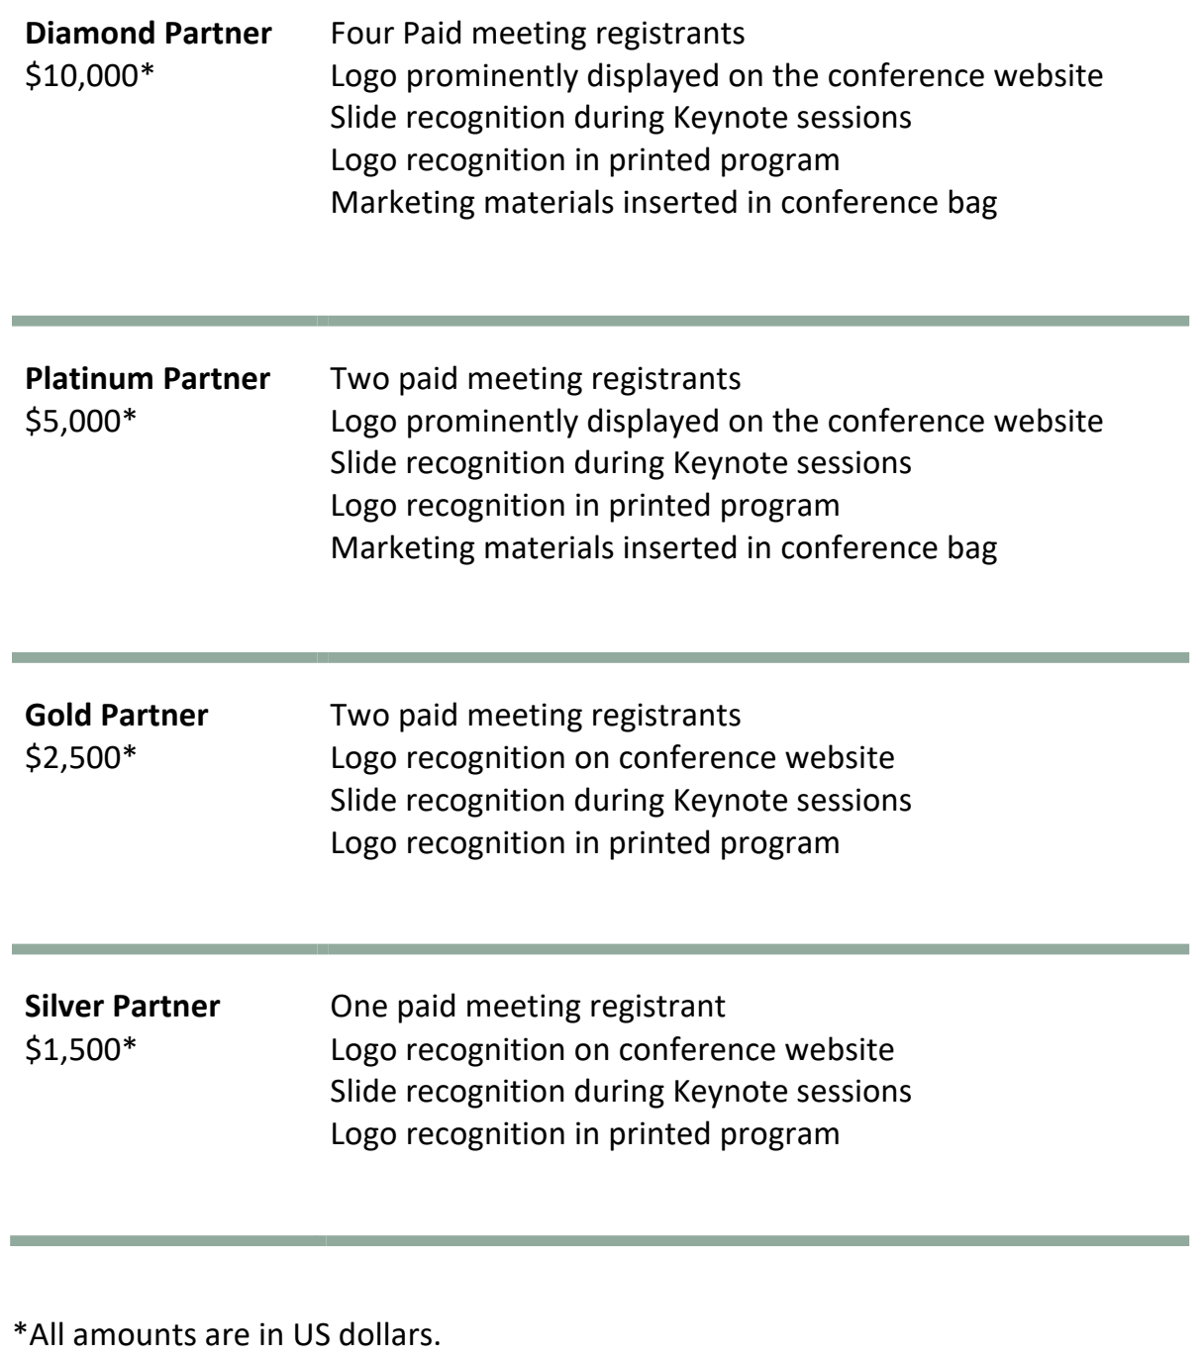
* All amounts are in US Dollars.

